
Leading Economic Indicators Up in April - June

Note: The issue with the building permit data has been resolved, so the USD Index should be coming out regularly again. The tentative date for the release of next month’s report is August 30.

August 1, 2012 -- The USD Burnham-Moores Center for Real Estate’s Index of Leading Economic Indicators for San Diego County rose in each month of the second quarter, with gains of 0.6, 0.7, and 0.1 percent respectively for April, May, and June. June’s slightly advance was led by a sharp increase in building permits along with moderate gains in consumer confidence and help wanted advertising. These outweighed moderate declines in initial claims for unemployment insurance, local stock prices, and the outlook for the national economy to push the USD Index to its eighth consecutive monthly increase, albeit by the slimmest of margins.

Although June’s advance was weak and the up/down ratio of the components was the worst in nine months, the outlook remains for positive growth in the local economy. The most encouraging news for the local economy was a solid jobs report for June. San Diego County added 24,000 more jobs in June compared to the same month in 2011. That was the best year-over-year job growth in a month since 2005. Barring an international event (Europe, China, the Middle East) that tips the national economy into a double dip recession, that job growth in expected to last the rest of the year and into at least the first half of 2013.

 |  | APR | MAY | JUN
 | Index of Leading Economic Indicators  The index for San Diego County that includes  the components listed below  Source: USD Burnham-Moores Center for Real Estate | +0.6% | +0.7% | +0.1%
 | Building Permits  Residential units authorized by building  permits in San Diego County  Source: U.S. Census Bureau | +0.19% | +1.74% | +1.25%
 | Unemployment Insurance  Initial claims for unemployment insurance in  San Diego County, inverted  Source: Employment Development Department | +1.22% | +0.05% | -0.76%
 | Stock Prices  San Diego Stock Exchange Index  Source: San Diego Daily Transcript | +0.14% | -0.11% | -0.41%
 | Consumer Confidence  An index of consumer confidence in San Diego  County , estimated  Source: The Conference Board | +1.87% | +1.12% | +0.38%
 | Help Wanted Advertising  An index of online help wanted advertising in  San Diego  Source: Monster Worldwide | +0.24% | +0.33% | +0.61%
 | National Economy  Index of Leading Economic Indicators  Source: The Conference Board | -0.20% | +0.81% | -0.61%

School of Business Administration
5998 Alcalá Park, San Diego, California 92110-2492 619/260-2256
Highlights: After a slow first quarter, residential units authorized by building permits picked up in the last few months to push into positive territory for the year overall. Residential units authorized are up 4 percent through the end of the first half compared to the same period in 2011. The trend continues to be weakness in single-family units authorized and strength in multi-family, with the former down 23 percent and the latter up 26 percent through the end of the second quarter. . . The labor market variables were mixed in June. Initial claims for unemployment insurance have mirrored the rise seen at the national level, which signals an increase in job loss and which is a negative for the Index. On the other hand, hiring continues to improve, with help wanted advertising increasing for the 18th month in a row and now at its highest level since September 2008. The net result was that the local unemployment rate was at 9.2 percent in June, which compares to a rate of 8.8 percent in May and 10.4 percent in June 2011. The increase in June was largely due to seasonal factors. Seasonally adjusted, the unemployment rate fell below 9 percent for the first time since March 2009. . . Despite weak numbers on the economy, consumer confidence continues to improve. The drop in gas prices heading into the summer likely improved the outlook for consumers. . . Despite declining in both May and June, local stock prices finished the first half of the year up 12.2 percent. This compares to gains of 5.4 percent in the Down Jones Industrial Average, 8.3 percent in the S&P 500 Index, and 12.7 percent in the NASDAQ Composite Index. . . The national Index of Leading Economic Indicators declined in two of the three months in the second quarter. Growth remains positive but weak, with the “advance” estimate for Gross Domestic Product for the second quarter showing a 1.5 percent annualized growth rate, which was down from an already weak 2.0 percent growth rate for the first quarter..

June’s increase puts the USD Index of Leading Economic Indicators for San Diego County at 121.4, up from 121.3 in May and 120.5 in April. For revisions to the previously reported values for the Index and for the individual components, please visit the Website address given below. The values for the USD Index for the last year are given below:

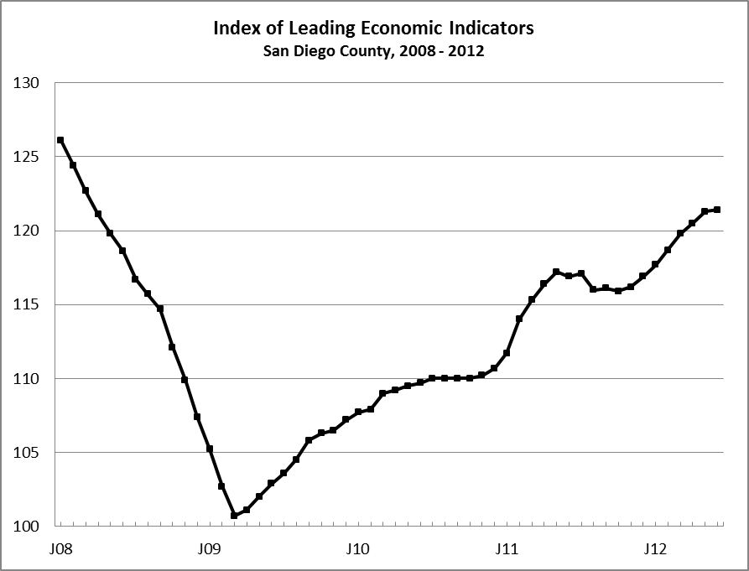
Index % Change

2011 JUN 116.9 - 0.2
JUL 117.1 +0.2
AUG 116.0 - 1.0
SEP 116.1 +0.1
OCT 115.9 - 0.2
NOV 116.2 +0.2
DEC 116.9 +0.6

2012 JAN 117.7 +0.7
FEB 118.7 +0.9
MAR 119.8 +0.9
APR 120.5 +0.6
MAY 121.3 +0.7
JUN 121.4 +0.1

For more information on the University of San Diego's Index of Leading Economic Indicators, please contact:

Professor Alan Gin TEL: (858) 603-3873
School of Business Administration FAX: (858) 484-5304
University of San Diego E-mail: agin@san.rr.com
5998 Alcalá Park Website: http://www.sandiego.edu/~agin/usdlei
San Diego, CA 92110 Twitter: @alanginusdsba

