Leading Economic Indicators Down in April
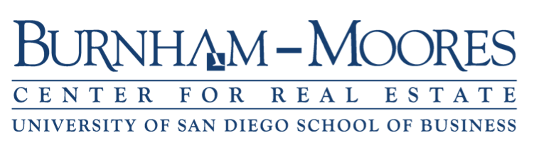

Note: The tentative release date for the report for May is June 28.

May 31, 2018 -- The USD Burnham-Moores Center for Real Estate’s Index of Leading Economic Indicators for San Diego County fell 0.2 percent in April. The move to the downside was led by a sharp drop in residential units authorized by building permits. Also down were online help wanted advertising and local stock prices. The other three components were positive, with the outlook for the national economy up moderately and initial claims for unemployment insurance and consumer confidence up slightly. But these were not enough to prevent the USD Index from suffering its first loss in 18 months.

Economists usually look for three consecutive changes in a leading indicators index to signal an upcoming turning point. So it remains to be seen as to whether April’s decrease is an aberration or a sign of things to come. For now, the outlook continues to be for a strong local economy through the end of this year and at least into the beginning of 2019. One thing that could negatively affect the local economy is the rising cost of gasoline. Heading into the Memorial Day weekend, gas prices were about 70 cents a gallon higher than they were a year ago. My estimate is that a one cent increase in gas prices translates into $1 million a month additional spending on gas, which means that San Diegans are spending an extra $70 million dollars on gas compared to a year ago. While that is not large compared to the local economy as a whole, that is money that could have been spent in the local economy on things like restaurants, retail, attractions, etc.

 | Index of Leading Economic Indicators  The index for San Diego County that includes  the components listed below (April)  Source: USD Burnham-Moores Center for Real Estate | -0.2%
 | Building Permits  Residential units authorized by building  permits in San Diego County (April)  Source: U.S. Census Bureau | -1.09%
 | Unemployment Insurance  Initial claims for unemployment insurance in  San Diego County, inverted (April)  Source: Employment Development Department | +0.23%
 | Stock Prices  Bloomberg San Diego County Index (April)  Source: Bloomberg Business | -0.20%
 | Consumer Confidence  An index of consumer confidence in San Diego  County , estimated (April )  Source: The Conference Board | +0.11%
 | Help Wanted Advertising  An index of online help wanted advertising in  San Diego (April )  Source: The Conference Board | -0.74%
 | National Economy  Index of Leading Economic Indicators (April)  Source: The Conference Board | +0.74%

School of Business
5998 Alcalá Park, San Diego, California 92110-2492 (858) 603-3873
Highlights: The decline in residential units authorized by building permits which started in March accelerated in April. The number of residential units authorized in April was actually up compared to March, even after seasonal adjustment. But the USD Index uses a moving average to smooth out the month-to-month fluctuations of the individual components. This gives a better indication of the trend in the components, particularly for a component such as building permits, which can fluctuate dramatically from month to month. . . The labor market variables were mixed during the month. Initial claims for unemployment insurance were positive for the seventh month in a row, but help wanted advertising fell for the first time in seven months. The net result was that the seasonally adjusted unemployment rate for San Diego County was 3.1 percent in April, which was down from 3.2 percent in March and from 4.1 percent in April 2017. The actual unemployment rate was fell below 3 percent to 2.9 percent, but April is usually the third best month of the year for the unemployment rate (behind December and May). . . Local stock prices remain volatile, like the broader market averages, and have now dropped in two of the last three months. . . The one consistent component remains consumer confidence, which has now increased for the 22 straight months. . . The national Index of Leading Economic Indicators moved in the opposite direction of the local index and pushed its positive or unchanged streak to 20 consecutive months. The national labor market remains strong, with the unemployment dropping below the four percent mark that economists view as full employment. Growth is still lagging though, with the second estimate of first quarter GDP growth at 2.2 percent. This was down from the “advance” estimate for the first quarter of 2.3 percent and the 2.9 percent rate in the fourth quarter of 2017.

April’s gain puts the USD Burnham-Moores Index of Leading Economic Indicators for San Diego County at 152.7, down from March’s reading of 153.0. Revisions in the national Index of Leading Economic Indicators for January and March affected the previously reported level of the Index for January. To view the previously reported values for the Index and for the individual components, please visit the Website address given below. The values for the USD Index for the last year are given below:

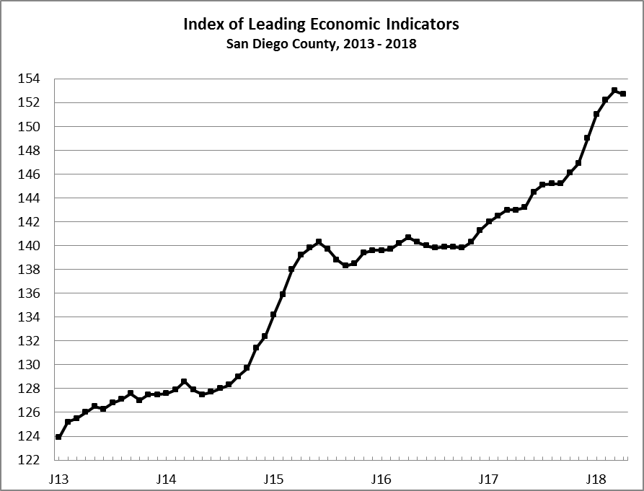
Index % Change

2017 APR 143.0 +0.0
MAY 143.2 +0.1
JUN 144.5 +0.9
JUL 145.1 +0.5
AUG 145.2 +0.1
SEP 145.2 +0.0
OCT 146.1 +0.6
NOV 146.9 +0.5
DEC 149.0 +1.4

2018 JAN 151.0 +1.4
FEB 152.2 +0.8
MAR 153.0 +0.5
APR 152.7 -0.2

For more information on the University of San Diego's Index of Leading Economic Indicators, please contact:

Professor Alan Gin TEL: (858) 603-3873
School of Business Administration FAX: (619) 260-4891
University of San Diego E-mail: agin@sandiego.edu
5998 Alcalá Park Website: goo.gl/CV7Stc
San Diego, CA 92110 Twitter: @alanginusdsba

