Summary:
The most integral concept we considered in creating a traffic-control method for roundabouts was efficiency. In high-density traffic areas, we came up with a unique solution which keeps traffic moving smoothly during rush hours and allows for free-flowing traffic at less concentrated times of the day: a stoplight that flashes yellow, indicating yield, on all incoming streets to the traffic circle when less than 60 cars are travelling through the intersection per minute. We also implemented stoplights on the interior of the traffic circle to prevent collisions and bottlenecking during busy times, when incoming stoplights are green. Opposing lights will mirror each other, and green incoming lights will indicate red interior lights on corresponding intersections. Our convertible light will increase efficiency a minimum of 35% of the day on intersections that require stoplights for their rush hours.
Introduction:
In analyzing the best way to direct traffic through a traffic circle, we considered issues of efficiency and safety. We found no difference in the amount of accidents occurring at yield signs vs. stop signs; actually, traffic circles have a lower accident rate and higher efficiency rate than four-way stops or stoplight-controlled intersections. According to Grile, the only difference between stop signs and yield signs was “a saving in road user costs of about 8% when switching from a stop to yield sign.” Therefore, we decided safety was not a main concern, and the goal was to maximize the efficiency, the amount of traffic passed through per unit time. We examined several different approaches, such as stop lights, stop signs, and yield signs, to find the best solution in a given scenario. Through our research, we discovered that many larger roundabouts do not utilize lanes and are controlled by either stoplights or yield signs.

Assumptions:
- The speed limit in and approaching all traffic circles is consistent; we used 50 km/hr.
- The interior of the traffic circle is closed to pedestrians, so no crosswalks are needed in the interior of the circle; crosswalks for individual streets would be placed at least 10m from the circle.
- There are no more than two incoming and two outgoing lanes of traffic for any given street.
- In a traffic light, 1 car can go through the light each second.
- Cars are coming consistently from all directions.
- All incoming streets have corresponding outgoing streets across the roundabout.
- Trucks are not allowed in the roundabout.
The Model:
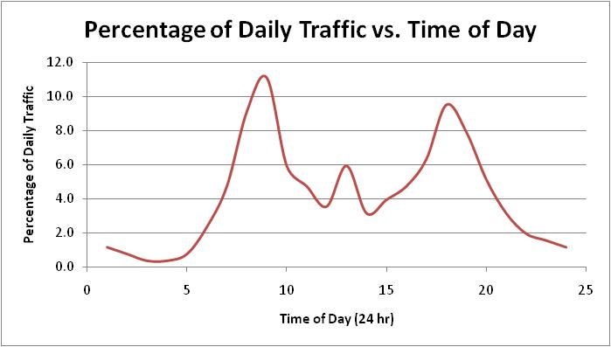

Solution 1:
We first determined that the two most relevant traffic control devices are yield signs and traffic lights. From our research, yield signs are most effective when there are less than 800 cars per day (Grile), which would, from the model, include places where rush hour doesn’t have more than 160 cars travelling through the intersection. Here, the city would save money in stoplights by adding only yield signs. In busier intersections, a stoplight should be used.
Solution 2:
We wanted to find a way to incorporate yield signs and stoplights for traffic circles with alternating intense and mild traffic flow at different times of the day. Thus, we came up with a new concept to hybridize the stoplight and yield sign by having the stoplight utilize its flashing yellow lights, performing as a yield sign when daily traffic is less than 800 cars. Also, as a safety precaution and prevention of bottlenecking, we decided to create an outer right-turn only lane throughout the circle; cars can turn into this lane but must merge as soon as possible unless they are turning.
Results:
See next page for technical summary.
Technical Summary Briefing:
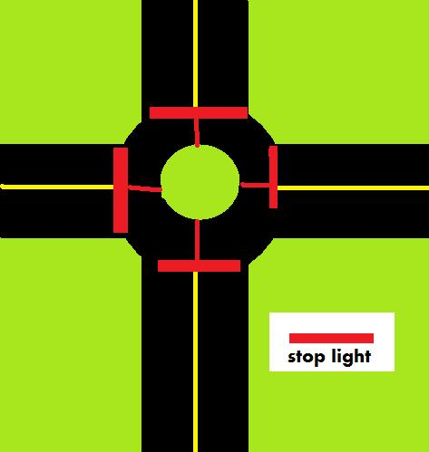
The following contains instructions on the implementation of a highly efficient traffic control method designed for traffic circles. At all intersections averaging more than 800 cars/day, a traffic light is to be installed at each incoming street and on the circle immediately following each incoming street, illustrated by Figure 1.2. If the traffic is lower than this, only a yield sign at each incoming street is necessary. These traffic lights will be controlled according to the time of day (T_{D}) and average amount of cars per day (C). Weekends will only necessitate a yield sign.
During rush hour, 06:00-10:00 and 16:00-19:00, the traffic light will function normally. The timing of the lights will be determined by the radius of the traffic circle. Smart lights should be used to minimize wait time.
Figure 1.2
The equations are:
- t=.4021r, where t is the time (s) for one car to travel the circumference (m) and r is the radius (m) of the traffic circle.
- Opposing lights will mirror each other, and each light will be green for .5t; the red lights will have a delay of an additional t/s, where s is the number of streets carrying through the intersection. Therefore, the time for one cycle of lights to be completed is .5t(s+1)
- Lights will turn green counter-clockwise; only 1 street (2 ways) will have green lights at a time.
- The incoming lights will always oppose the lights in the circle.
- If incoming traffic per minute is less than 60 vehicles, traffic can flow normally without needing a stop light, so all in-circle lights will remain green and all incoming lights will flash yellow, signaling yield. Incoming traffic per minute is P(T_{D})C/60; percentage of daily traffic, according to time of day, times average daily traffic over 60. P(T_{D}) can be found by the following graph:
**This is a general trend in daily traffic, which can be specialized to your city and intersection.

Examples:
- In a busy intersection with four cross-streets, such as monument areas, the radius of the circle is 75m and, on average, 100,000 cars travel through the circle per day.
- The time for one car to circulate the intersection would be 30.2 s.
- During rush hour traffic at 8 am, incoming traffic would by approximately 183 cars per minute.
- Each light will be green for 15.1 s and red for 18.9 s.
- The time for one cycle would be 75.5 s. If each street had two lanes, the roundabout would pass through 151 cars per cycle.
- In a semi-busy intersection with two cross-streets, the radius of the circle is 50m and, on average, 20,000 cars travel through the circle per day.
- The time for one car to circulate the intersection would be 20.1 s.
- At 9 pm, incoming traffic would by approximately 13 cars per minute.
- Therefore, each incoming street will have a flashing yellow light for yield, while the in-circle lights remain green.
Conclusion:
Our second solution is more feasible than our first solution by way of efficiency. Even in an extremely busy intersection traversed by 100,000 cars per day, the stoplight will be functioning more efficiently 37.5% of the day by becoming a yield light. At low traffic intersections, a yield sign is more effective and less costly for the road user. However, a busy traffic circle necessitates a stoplight to allow all traffic a turn. By having opposing lights mirroring each other and all in-circle light except the ones corresponding to the green incoming lights green, traffic can flow in the circle without conflicting with incoming traffic. The lag time between green lights allows the last car coming into the circle on a green light time to get past the next light to turn green. If we had more time and resources for collecting data, we would have created a more in-depth approach to handling crosswalks, an odd number of incoming streets, busy weekends, and inconsistency in the amount of traffic coming from different directions. Overall, we are confident that our solution would provide a good base model to build upon in the future.
References:
http://www.oregon.gov/ODOT/HWY/TRAFFIC-ROADWAY/docs/pdf/Stop_Yield_Report.pdf

