**Solution to Problem A: Designing a Traffic Circle**

**Introduction:**

In order to design a traffic circle that maximizes traffic flow in ,out and around the circle we considered the options that are currently available to control traffic. That is we quantitatively and qualitatively analyzed the consequences of having yield signs, stops signs and traffic lights. After exploring these different possibilities we came to realize that designing a traffic circle that acknowledges the safety of commuters would also realize the goal of traffic efficiency in, out and around our circle.

We decided that for our designs we would implement traffic lights as our means of traffic control. The reason we chose to only utilize traffic lights is due to the fact that they offer a vast array of options. In other words there are far more options to controlling traffic with lights than with a traffic sign like a stop sign or yield sign which does not offer the dynamic response to a situation that a signal light offers. Our designs were based on the fundamental idea of creating a dynamic, intelligent system that had the power to adapt to any traffic situation given certain inputs of data from its surrounding environment. The following assumptions were made in developing our designs: the user/commuter will follow the rules that are designated in our traffic circle at any given time, the area beyond the traffic circle was not considered i.e. the traffic or lack there of coming from lanes leading into the circle say from a freeway or street, the cost of the design was secondary in terms of priority to that of commuter safety and traffic flow efficiency, the technology that is utilized in this design is both available, easily implemented and can handle the scope as well as detail of the design.

**Design A:**

Our first design employs four bypass lanes that are strategically located at the four entrances of our traffic circle. See Figure 1 for more detail. In addition our traffic circle applies the use of an emergency shoulder lane in the center of the circle along with four distinct merge lanes that can also be seen in the data section of the report. The emergency shoulder lane provides the commuter with a place to turn off in the event of a vehicle malfunction or for medical emergency purposes. The merge lanes are used to maximize the flow of incoming traffic while minimizing the effect that this incoming traffic has on traffic flowing around the circle. The main problem with modern traffic circle design is that the flow of traffic around the circle adversely affects the flow of incoming traffic or vice versa. This problem is manifested when cars attempt to merge from one lane to another. One of the goals of our design is to minimize merging i.e. the car to car encounters that occur with incoming traffic and traffic around the circle. See data section for a visual representation of the aforementioned. Due to time constraints we were not able to full document Design B or C.

The intelligent system that we propose to implement in modern traffic circles is one that is based on a variety of sensors. The sensors that we would use to collect data from our environment would be based on pressure readings and ultrasonic readings. The pressure readings and ultrasonic readings would allow us to quantitatively analyze the status or condition of traffic in the circle at any given time. These data inputs would communicate with our traffic lights which would respond according to the situation or status of our traffic circle. In other words the light intervals or duration that any given light is either green, yellow or red would depend on the readings from our sensors. We propose that our ultrasonic sensor be located above traffic requiring some sort of roof or ceiling structure. The pressure sensor should be located beneath traffic and may also utilize capacitance or inductance to gauge traffic conditions. The pressure sensors requiring a reasonable amount of accuracy and sensitivity would use area and pressure data to calculate the force exerted on the ground by each vehicle. Using the force the mass of the vehicle would be calculated using Newton’s Law and the acceleration of the vehicle which would be given by an ultrasonic reading. Given the mass a computer would then analyze a data bank of car information and using a sorting algorithm would find the vehicle corresponding to the mass. The computer would then be able to retrieve the dimensions of the vehicle and then calculate the area that the vehicle would require. Then the computer would store that information in a variable such as c1 and then would proceed to analyze the data for the next car, and the next car and so on, storing the information in variables. At the same time the computer would sum the areas and subtract them from the total area of the traffic circle. This would allow us to know how many cars are on the traffic circle at a given time. Given this information along with the acceleration or speed readings gathered by the ultrasonic sensor the system could intelligently decide when and for how long it should make the lights turn red and thus cut the flow of incoming traffic. The idea is that a computer or more likely a series of computers would have information stored on them like the carrying capacity of the traffic circle and the minimum speed associated with a certain number of cars before the lights turned red. Using this combination of information our system could gauge both precisely and accurately the conditions within our traffic circle; from the data collected from each car in the circle the system would output a speed to a screen that would be strategically located for optimal visibility on each incoming lane to the traffic circle. The speed outputted to the screen would be the speed that would best suited to minimized car encounters and merging between incoming traffic and traffic around the circle.

Eight traffic lights are located near the four entrances of the circle. Four of the traffic lights control the incoming traffic the other four lights control traffic around the circle. The main function of the four traffic lights that control traffic into the circle are to alleviate traffic conditions by halting incoming traffic at certain times. See data section of report for a visual schematic of sensor placement and screen location.

The aforementioned ideas were based on a fluid model that we developed and tested in order to inform our decisions in regards to controlling traffic with the lights. In our fluid model each of the four entrances were symbolically represented as valves that could be either opened or closed. Water was used as the fluid to represent traffic. As expected when the water in our circle became built up and occupied all of the area than no water/traffic could enter. In order to alleviate the traffic build up one of the valves was opened. We found as expected that the more valves that were opened the more water we could pass through our circle. In other words the flow of incoming traffic is directly proportional to the flow of outgoing traffic. To analyze the relationship between the flow around the circle and the flow of incoming traffic different colored beads were placed in our fluid model. Red beads were used to represent traffic inside the circle and blue beads represented traffic that was entering the circle. As expected the red beads and blue beads collided randomly and then mixed and flowed together. From this simple model our original assumptions were confirmed; the major issue with traffic circles is the relationship between incoming traffic and traffic around the circle. Our model suggests that there is a negative relationship between the two and that priority should be given to the traffic inside the circle.

From the data and the analysis derived from our fluid model we decided on developing a set of rules or guidelines that the traffic lights would present to the commuters. The first of these rules is that each commuter can only complete one revolution in the circle, the second is that each commuter must adhere to the designated speed based on traffic conditions outputted on the traffic screen, the third is that each commuter must use the turn off shoulder in the case of an emergency and the fourth rule is that only two lights out of the four will be green at a given time and these two lights will be the lights opposite each other in the circle. See data section of report.

The north and south lights will be green while the east and west lights will be red and vice versa. In addition the traffic lights within the circle will all be green while the two opposing lights are green, however, when the cars complete one revolution around the circle and reach the entrance from which they entered the light within the traffic circle will be red with a green arrow which will enabled the commuter to make a turn and exit the circle. This rule will be implemented because we are assuming that the commuter will be able to easily access the exit that they desire due to the fact that there will be no incoming traffic while they are completing their revolution around the circle. If it is easy to access the exit of their chose there is no need to complete more than one revolution around the circle. This rule is consistent with the results dictated by our fluid model, that the priority should be given to the traffic around the circle.

**Summary:**

The goal of our design was to maximize the efficiency of traffic flow in, out and around our traffic circle. In order to achieve this goal we analyzed the different ways in which we could minimize car on car interactions that occur with incoming traffic and traffic around the circle. The data and the analysis that was conducted was based on statistics gathered from traffic circles in the United States and from a fluid model which we developed in order to test out the basic flow interactions that occur in, out and around a traffic circle. From this data we developed a set of rules or guidelines that commuters would be required to follow in order to maximize safety and traffic flow efficiency. Lastly and most challengingly we developed a dynamic, intelligent design that relies on input readings from the traffic environment via pressure, ultrasonic and electrical sensors that communicate to a series of computers. These computers quantitatively analyze with specific algorithms the data that is collected; using the data the computers dictate traffic control through the use of traffic signal lights. Several designs were developed that each are defined by the aforementioned ideas. The designs vary in the use of traffic lights but all share the common foundation of an intelligent system that is able to logically think its way through a number of real world situations based on data input readings from commuters using traffic circles. Design A performed 86% better than the Design B or Design C based on our fluid model and mathematical analysis. Due to time constraints we were not able to full document Design B or C. Lastly if the intelligent design program fails or malfunctions, there can always be a manual override.

**DATA (Diagrams, Calculations, Graphs and Simulations)**

Figure 1: Circle with Bypass Lanes and Traffic Lights

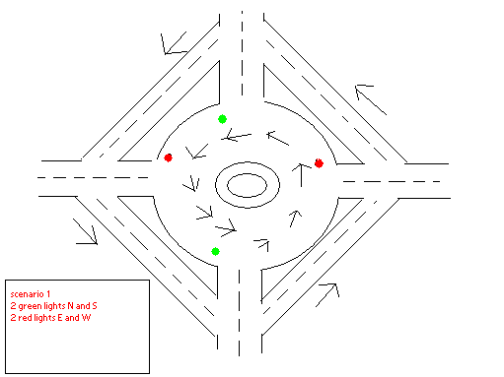

Figure 2: Circle with Bypass Lanes and Traffic Lights

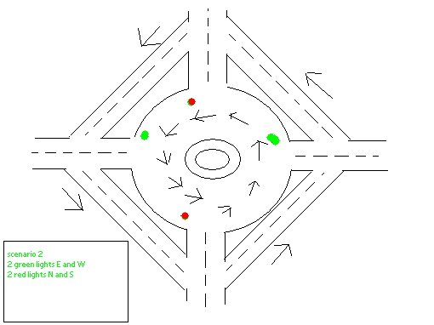

Figure 3: Traffic Circle with eight signal lights, four traffic screens, merge lanes and emergency turn off lane

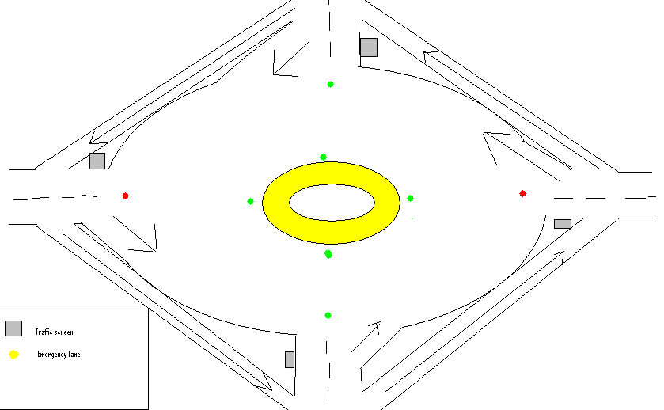

Figure 4: Traffic Flow Estimations (I)



Figure 5: Traffic Flow Estimations (II)



Traffic Program Simulation done using Microsoft Visual Studios (C++)

Main()

Double speed_sensor, time_elapsed

Int time_green;

Char N,S,E,W

If(speed_sensor >=25) “if the speed sensor detects cars going more than 25 miles per hour, it will set the time of the lights to 30 seconds.”

Time_green=30;

N and S = green;

E and W = red;

“The program loops every 30 seconds and changes the N and S lights to red and the E and W lights to green.”

If Time_elapsed =30

N,S = red;

E,W=green;

Else if (speed_sensor 20<<ss<<25) “otherwise, if the speed sensor detects cars moving at a speed inbetween 20 and 25 miles per hour, it will set the time of the green lights to be 20 seconds.

Time_green = 20

“Change value for time_elapsed;”

Else if(speed_sensor 15<<ss<<20)”The speed sensor changes the time period of the lights if cars are going between 15 and 20 miles per hour. The time of a green light will now be 15 seconds.

Time green=15;

Change time_elapsed value to 15)

Else if (ss<<10)

N,S,E,W = red;

“this is to flush out the cars if the speed sensor detects a speed less than or equal to 10 miles per hour. “

Figure 6: Fluid Model for Traffic Analysis

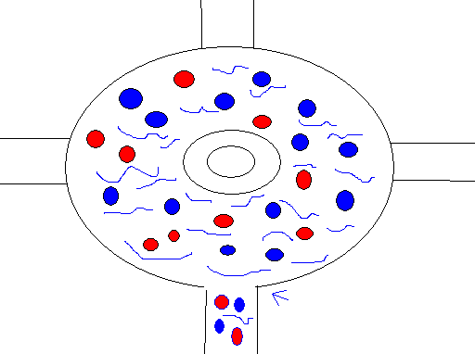

**Works Cited**

Gill, T. Grandon. Introduction to Programming Using Visual C++.NET. Hoboken: John Wiley & Sons, Inc., 2005.

Hibbeler, R.C. Engineering Mechanics: Statics. 11th ed. Upper Saddle River: Pearson Prentice Hall, 2007.

Moran, Michael J., Howard N. Shapiro, Bruce R. Munson, and David P. DeWitt.

Introduction to Thermal Systems Engineering: Thermodynamics, Fluid Mechanics, and Heat Transfer. Hoboken: John Wiley & Sons, Inc., 2003.

Savitch, Walter, and Frank M. Carrano. Java: An Introduction to Problem Solving & Programming. 5th ed. Upper Saddle River: Pearson Education, Inc., 2009.

Serway, Raymond A., and John W. Jewett, Jr. Physics for Scientists and Engineers with Modern Physics. 7th ed. Belmont: Thomson Learning, Inc., 2008.

Stewart, James. Essential Calculus: Early Transcendentals. Belmont: Thomson Brooks/Cole, 2007.