Guide to Standard Cloning Technique

RI GENOMICS & SEQUENCING CENTER
University of Rhode Island
352 CBLS - 120 Flagg Road
Kingston, RI 02881
CONTENTS

Section 1. Designing Primers
Part A. Basic design 3
Part B. Adding restriction enzyme cut sites 5
Part C. Checking the amplified region (control) 9
Section 2. Using Restriction Enzymes
Part A. Single restriction enzyme efficiency (control) 11
Part B. Double restriction enzyme efficiency (control) 13
Section 3. CIAP Control 14
Section 4. Ligation Controls 14
Section 5. Transformation Controls 15
Section 6. Flow Charts Packet #2

The purpose of this guide is to document the process of cloning a genetic region of interest (ROI), digesting the region using restriction enzymes and subsequently ligating the ROI into a plasmid. This guide will provide a list of controls and suggestions that should be followed.

Created by Ted Spinard, Kingston, RI, October 2013
Section 1: Designing Primers
Part A. Basic design

Overview: In order to clone a genetic region of interest (ROI), two primers must be constructed such that the primers will amplify the sequence between them. If the cloned genetic ROI is to be inserted into a plasmid, restriction cut site sequences are often added to the primers. The following checklist should be followed.

Primer design checklist:
- Construct forward and reverse primers
- Primers share a similar T_{m} value
- Primers do not form strong secondary structures
- Primers do not end in a stretch of A's
- Primers are 18 to 35 bp long
- When adding a restriction enzyme cut site
  - Primers have a 6 bp buffer zone
  - Primers have compatible restriction enzyme sites
  - Primers contain ~21 bp region homologous to the region of interest

A good tool to design primers easily can be found at www.ncbi.nlm.nih.gov/tools/primer-blast/. Input the specified information using the checklist above and use the detailed subsections below as a guide. Restriction enzyme cut site sequences can be manually added later.

Forward and reverse primers:

Amplifying a genetic ROI requires a forward and a reverse primer. This is illustrated in the graphic below. The forward primer (green) has a homologous sequence to the positive strand. The reverse primer (red) has a sequence that is homologous to the negative strand. The reverse primer’s sequence is a reverse compliment to the positive strand.
If we zoom-in to the sequences corresponding to the primers, they will look like this.

Positive strand: 5’-CAGGAAACAGCTATGACCATGATTACG-3’
Forward primer: 5’-CAGGAAACAGCTATGACCATGATTACG-3’

Positive strand: 5’-AGGGCCCAATTCGCCCTATA-3’
Reverse primer*:
*(design/order the 5’ to 3’ sequence: 5’-TATAGGGCGAATTGGGCCCT-3’

Similar T_{m} value:

T_{m} is the melting temperature at which half of the primer will dissociate from the template and become single stranded DNA. In order for a genetic ROI to be correctly amplified, the T_{m} values must be similar. Optimal T_{m} values are between 52 - 58º C. The T_{m} values should be within 5º C , but exceptions can be made.

Primers do not form strong secondary structures:

The potential to form secondary structures can be determined by checking your primer sequences at www.idtdna.com/analyzer/Applications/OligoAnalyzer/

Primers can form two types of secondary structures: dimers and hairpins. A self-dimer is expected to form in primers containing a restriction cut site because these sites are palindromes. The primers should still work, however, if this is the primary self-dimer. Generally, the ΔG values of a dimer should be more positive than -9, however this may not be possible. Dimers may also form between 2 different primers.

The T_{m} value of the hairpins should be lower than the annealing temperature of the reaction. The annealing temperature is calculated as Primer T_{m} – 5º C.

The two types of secondary structures are illustrated below:

Self-dimers
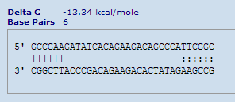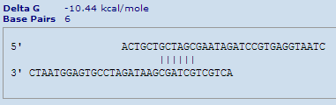

HairPin

Primers do not end in a stretch of A's:

Primers that end in a stretch of A’s are more likely to be degraded.

Part B: Adding restriction enzyme cut sites:
The basic design of a primer containing a restriction enzyme cut site and its regions are shown below.

GCC GAA GAT ATC ACA GAA GAC AGC CCA ATC AAT
(Buffer) (Restriction) (Homologous region)

Homologous region: A ~21 bp region that is homologous to the genetic region of interest.

Restriction enzyme recognition site: This is a specific 6 bp site recognized by the restriction enzyme. The plasmid and primers will contain the same restriction cut sites. This allows the cloned DNA fragment to ligate into a plasmid as illustrated below. For more information on choosing restriction enzymes, see “Checking the compatibility of the restriction enzymes” below.

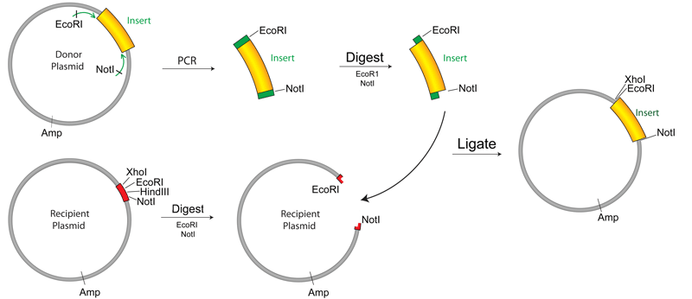

Buffer zone: Some restriction enzymes are not efficient at cutting near the terminus of a DNA sequence. Accordingly, a nonsense buffer sequence is included in the primer. The sequence can be changed to adjust the primer’s T_{m} values. Check the manufacturer's recommendations for each enzyme.

Checking the Compatibility of the Restriction Enzymes:

Overview: If two restriction enzymes are to be used, the enzymes and the cut sites must be compatible. The following list should be followed.

General enzyme compatibility checklist:
- The restriction site does not occur in the DNA fragment to be amplified
- The restriction site occurs once on the plasmid
- The restriction site does not occur in a functional sequence on the plasmid
- The restriction site does not occur in the buffer region of either primer
If using 2 enzymes:
  - There is no star activity in the shared buffer
  - They will not create the same sticky end sequences
  - (Optional) The enzymes share the same buffer
  - (Optional) The cut sites are separated by less than 40 base pairs (bp) on the plasmid
If using 1 enzyme:
- Use CIAP (calf intestinal alkaline phosphatase; see Section 3)

The restriction sites do not occur in the DNA region to be amplified:

The cut sites cannot occur in both the primer and the DNA region you wish to ligate into a plasmid.

The restriction sites only occur once on the plasmid:

In most instances, the cut sites can only occur once in the plasmid. This will prevent the generation of multiple plasmid fragments.

The restriction site does not occur in a function sequence:

The cut sites should not occur in functional sequences (i.e. origins of replication, genes needed for plasmid replication, antibiotic resistance genes, etc.)

The restriction site does not occur in the buffer region of either primer:

When designing the buffer region, do not accidently add a cutting site for either restriction enzyme.

Star activity:

To check for star activity visit:
https://www.neb.com/tools-and-resources/interactive-tools/double-digest-finder
or
www.promega.com/guides/re_guide/RESearch/default.aspx?search=buffer
and selected your 2 restriction enzymes of interest.

Star activity refers to a restriction enzyme cutting in a non-specific manner. When checking for enzyme buffer compatibility, star activity will be indicated as below.

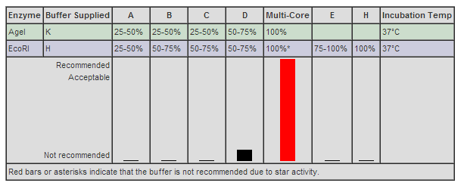

Restriction enzymes will not create the same sticky ends:

Some enzymes recognize different cut sites but will create the same sticky end. This should be avoided. This concept is illustrated below by examining the enzymes SalI and XhoI.

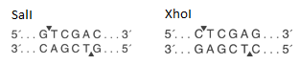

Enzymes share the same buffer:

To check for buffer compatibility visit:
https://www.neb.com/tools-and-resources/interactive-tools/double-digest-finder
or
www.promega.com/guides/re_guide/RESearch/default.aspx?search=buffer
and select your two restriction enzymes of interest.

The two enzymes should share a compatible buffer. In the example below, the enzymes are compatible in buffer D or buffer H. If they do not share a compatible buffer and these are the only two usable enzymes, the two digestions can’t occur at the same time. After digestion with the first enzyme, the product will have to be purified before proceeding with the second digestion. The downside to doing separate reactions is a decrease in yield of the final product.

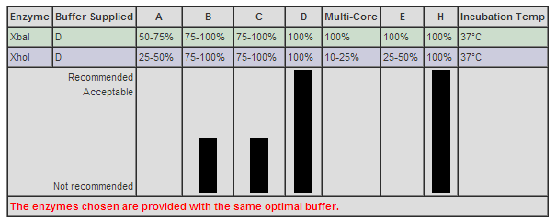

The cut sites are separated by less than 40 base pairs (bp) on the plasmid:

The cut sites on the plasmid should be separated by less than 40 bp. If they are separated by more base pairs, PCR column purification will not work because the short fragments will be purified along with the cut plasmid. This will cause problems in the ligation step. If this is the only option, the fragments will have to be separated by running the product on an agarose gel and subsequently purifying the correct size fragment of interest. Purifying DNA from gel greatly reduces your final yield.

Using one restriction enzyme:

After digesting and purifying the plasmid, the use of calf-intestinal alkaline phosphatase (CIAP) is recommended. CIAP will remove the 5' phosphate groups from DNA strands. Only the cut plasmid should be treated (not the cut PCR product). If the plasmid is treated with CIAP, self-ligation will decrease but the untreated DNA fragment will be able to ligate into the plasmid.

Part C. Checking the amplified region
Overview: After performing PCR, the product must be run on an agarose gel to ensure that the correct region was amplified. If the PCR was done correctly the result will be a single band of the correct size.

Below is an example of basic PCR set up. The annealing temp is specific to the lowest primer T_{m} value. The elongation time is based on the size of the region to be amplified. For every kb, the elongation time should increase by 1 min. For example a 2.5 kb amplified region should have an elongation time of 2 minutes 30 seconds. The standard number of cycles ranges from 25 to 35.

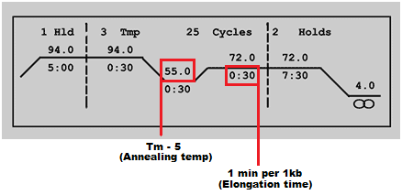
After performing PCR, the product should be run on an agarose gel and visualized to determine if the fragment is the correct size and if nonspecific bands are present. Below are images of two different PCR products run on agarose gels.

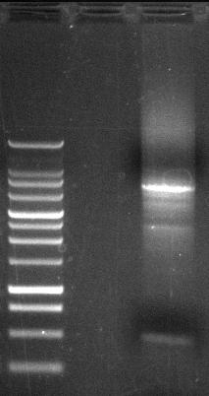

The image on the left shows a single band at the expected size when compared to the standard. The image on the right is an example of a bad PCR reaction showing multiple products or bands. If there are nonspecific bands or no bands you can tweak the parameters mentioned below. If there is a strong band at the correct size that can be isolated from the nonspecific bands you may choose to extract the correct size fragment from the gel. This is not an ideal solution because you will lose a lot of product in gel purification compared to PCR column purification.

Primer efficiency checklist:
- There should be only one band of the correct size in gel electrophoresis
- If there are multiple bands
  - Try reducing the number of cycles
  - Try using a longer elongation time
  - Try changing the annealing temperature to T_{m} – 2ºC
  - Try changing the Mg₂Cl₂ concentration
  - Extract the correct size fragment from the gel
  - Design new primers
- If there is no band
  - Try increasing the number of cycles
  - Try changing the annealing temperature to T_{m} – 2ºC
  - Try using a longer elongation time
  - Try changing the Mg₂Cl₂ concentration
  - Design new primers
Section 2. Using Restriction Enzymes
Part A: Determine individual restriction enzyme efficiency

The efficiency of the restriction enzymes must be determined before proceeding with any cloning steps. To test the efficiency, each restriction enzyme should be tested separately with the same conditions that will be used during the cloning steps (e.g. buffer, plasmid amount, incubation time, etc.). The digested plasmids should be run on an agarose gel and compared to an uncut plasmid in order to determine the cutting efficiency of the enzyme. (Be sure to read Section1, Part B: “Adding restriction enzyme sites” to prevent any restriction enzyme problems.)

Restriction enzyme efficiency checklist:

Test each restriction enzyme separately and run the products on an agarose gel
- The cut plasmid should appear as one band at the correct size
  - If there are multiple bands
    - If the multiple bands are similar to the uncut plasmid then the restriction enzyme is not working at 100% efficiency
    - Try a different buffer. This may prevent a double digestion: See Checking the compatibility of the restriction enzymes
    - The enzyme may have expired
  - If the multiple bands do not relate to the uncut plasmid
    - The restriction site is located at multiple places on the plasmid
    - The enzyme has star activity
    - There could be contamination of other restriction enzymes
  - If there is a single band of incorrect size
    - The restriction site is located at multiple places on the plasmid
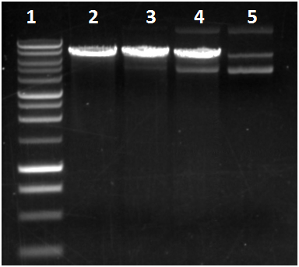

The image above shows a 1 kb ladder (lane 1), efficiently cut plasmid (lane 2), poorly cut plasmid (lanes 3 and 4), and uncut plasmid (lane 5). In lane 5 the uncut plasmid appears as three bands. The largest band corresponds to a plasmid dimer. The middle band is a nicked plasmid. The shortest band is a super coiled plasmid. In lane 2 a single cut plasmid shows a single band running at the appropriate length. Notice how in lane 3 and 4 there are multiple bands. These digestions were not 100% efficient. Using an old enzyme or incompatible buffer could cause this problem. Efficiency may be improved by using a different buffer. However, if the buffer is changed there may be a compatibility issue with the other restriction enzyme. In this case the digestions will have to occur separately.

Part B: Determine double restriction enzyme efficiency

Restriction enzyme efficiency checklist:

Test the restriction enzymes together and run the products on an agarose gel
- There is a single band
  - Is the distance between the restriction enzyme cut sites below 40bp?
    - Yes: PCR column purify the digestion
    - No: Gel extract the correct size band
- There are multiple bands
  - Gel extract the correct size band
If the two restriction enzymes are compatible (as described earlier in this guide) the efficiency of the enzymes can be determined by digesting with 2 restriction enzymes simultaneously. This step is identical to what you will be doing during the cloning steps. There should be one or multiple bands depending on the number of base pairs that separate the restriction cut sites. If there is a single band and the distance between the restriction cut sites is below 40 bp, the digested product can be purified by using a PCR column purification kit. If there are multiple bands or the cut sites are separated by more than 40 bp then the correct size fragment must be gel purified.

Section 3. CIAP Control
Overview: If you are cutting with one restriction enzyme, the linearized plasmid should be treated with CIAP. CIAP removes the 5’ phosphate end and will prevent circularization of the plasmid. Without CIAP, it is unlikely your PCR will ligate into the plasmid. The cut PCR product should never be treated with CIAP.
Determine CIAP efficiency

Positive control: (Note: transformation controls should be run first to ensure the cells are competent. Also, ligation controls should also be run to ensure the ligase is working). Generate a linear plasmid by cutting with a single restriction enzyme that cuts the plasmid once. Purify the digestion using PCR column purification. Treat the plasmid with CIAP. Purify the digestion using PCR column purification. Transform the cells with this plasmid and plate on selective medium. You should see few if any colonies.

Suggestions to improve CIAP efficiency:
- Ensure you have a high concentration of cut plasmid and cut PCR product because you will lose DNA after the purification
Section 4. Ligation Controls

Overview: The purpose of the ligation step is to covalently bind the cut PCR product to the linearized plasmid. After a successful ligation the plasmid will contain the PCR product. Before cloning, a few controls must be run.

Determine ligase efficiency

Positive control: (Note: transformation controls should be run first to ensure the cells are competent). Generate a linear plasmid by cutting with a single restriction enzyme that cuts the plasmid once. Purify the digestion using PCR column purification. Treat the plasmid with ligase. Transform the cells with this plasmid and plate on selective medium. You should see hundreds of colonies.

Negative control: (Note: transformation controls should be run first to ensure the cells are competent). This control should be run simultaneously with the positive control. Generate a linear plasmid by cutting a single restriction enzyme that only cuts the plasmid once. Purify the digestion using PCR column purification. Do not treat with ligase. Treat the cells with this linear plasmid and plate on selective medium. You should see few, if any, colonies.

Suggestions to improve ligase efficiency:
- Follow the manufacturer's recommendations.
- Ensure you have a high concentration of cut plasmid and cut PCR product. 12 ng/µl of plasmid should be sufficient, but more is always better
- Try using a different ratio of PCR product to plasmid.
- Incubate for a longer time may help
- Inactivate the ligase by incubating it at the high temperature indicated in the protocol for your ligase

Section 5. Transformation Controls

Overview: Competence is the ability for cells to take up extracellular DNA. Bacterial cells must be grown and prepared in a specific manner to induce competence. Over time, the cells may lose competence so it is essential that transformation controls are run.

Determine cell competency

Positive control: Transform the cells with uncut plasmid and plate on selective media. There should be a lawn of colonies.

Negative control: Streak cells without plasmid onto selective media. There should be no colonies. If there are colonies then the cells are resistant to the antibiotic on the plate or the plates have expired. Certain antibiotics such as ampicillin and tetracycline will expire after 2 weeks at 4º C.

Suggestions to improve transformation efficiency:
- Immediately following transformation, incubate in media to recover the cells. Do not allow the cells to sit without media.
- After transformation incubate with S.O.C media. This is a rich medium that will recover the cells better than LB media
- Before plating, centrifuge the cells and re-suspend in about 100 µl of media. This will create a higher concentration of cells.

