Leading Economic Indicators Up Slightly in August
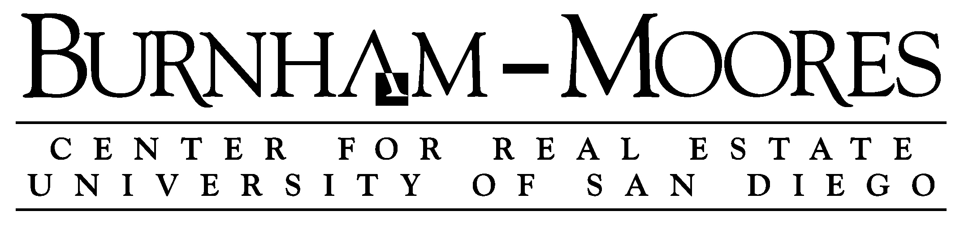

Note: The tentative release date of next month’s report is October 31.

September 30, 2016 -- The USD Burnham-Moores Center for Real Estate’s Index of Leading Economic Indicators for San Diego County rose 0.1 percent in August. The gain was led by a strong gain in local stock prices. There were also moderate increases in residential units authorized by building permits and consumer confidence. These outweighed a big drop in help wanted advertising and small losses in initial claims for unemployment insurance and the outlook for the national economy to push the USD Index to a gain which broke a streak of three consecutive monthly declines.

There was a little concern last month as the USD Index declined for the third month in a row. Economists would normally consider that a sign of a negative turning point in the local economy. That was tempered by the fact that the change was small and that there were more up components in July than down components. The gain in August validated the non-turning point view, but it was close, with the gain being small and with declining components matching advancing ones. The outlook for the local economy remains positive, but the rate of growth is likely to slow. The growth rate of employment is already slowing, with year-over-year job growth for August being roughly 25,000 after being at 40,000 earlier in the year. There is nothing structurally wrong with the local economy, but the recovery is now starting its seventh year (year-over-year job growth turned positive in July 2010) and it would be understandable if employment growth slowed compared to earlier in the recovery.

 | Index of Leading Economic Indicators  The index for San Diego County that includes  the components listed below (August)  Source: USD Burnham-Moores Center for Real Estate | +0.1%
 | Building Permits  Residential units authorized by building  permits in San Diego County (August)  Source: U.S. Census Bureau | +0.63%
 | Unemployment Insurance  Initial claims for unemployment insurance in  San Diego County, inverted (August)  Source: Employment Development Department | -0.11%
 | Stock Prices  Bloomberg San Diego County Index (August)  Source: Bloomberg Business | +1.00%
 | Consumer Confidence  An index of consumer confidence in San Diego  County , estimated (August)  Source: The Conference Board | +0.46%
 | Help Wanted Advertising  An index of online help wanted advertising in  San Diego (August)  Source: The Conference Board | -1.25%
 | National Economy  Index of Leading Economic Indicators (August)  Source: The Conference Board | -0.32%

School of Business Administration
5998 Alcalá Park, San Diego, California 92110-2492 858/603-3873
Highlights: August saw the most residential units authorized by building permits in a single month in over 10 years. The 1271 units authorized in the month (188 single-family, 1,083 multi-family) was the highest number since June 2006 and was strong enough to break a five month downward trend in building permits. The volatility in this component is illustrated with this strong result coming after a very weak month of July. It may have come down to a developer filing the permit at the beginning of August as opposed to the end of July. . . The labor market components were both negative in August. Job losses picked up slightly as initial claims for unemployment insurance flipped back to the downside after being positive in July. Help wanted advertising continued to slump, tallying a fifth consecutive decline. Despite that, the seasonally adjusted local unemployment rate was 4.8 percent in August, which was down from 5.0 percent in July and from 5.0 percent in August 2015. . . After breaking an eight month slide with a gain last month, consumer confidence tacked on another gain this month. A low unemployment rate, good job growth, and stable gas prices all could be contributing to a more positive outlook by consumers. It remains to be seen whether the outcome of the presidential election will have an impact on the confidence of both consumers and investor (as reflected in stock prices). . . Local stock prices advanced for the third straight months as investors remain positive about the outlook for San Diego companies. . . After a couple of good months, national Index of Leading Economic Indicators decreased in August. Job of 151,000 for the month was solid but not spectacular. The third estimate of GDP growth saw the national economy grow at a 1.4 percent annualized rate in the second quarter. This compares to the “advance” estimate of 1.2 percent and the second estimate of 1.1 percent.

August’s decrease puts the USD Index of Leading Economic Indicators for San Diego County at 139.9, down from July’s reading of 139.8. There were revisions in the national Index of Leading Economic Indicators for June and July, but that was not enough to affect the previously reported values or change in the Index for those months. For revisions to the previously reported values for the Index and for the individual components, please visit the Website address given below. The values for the USD Index for the last year are given below:

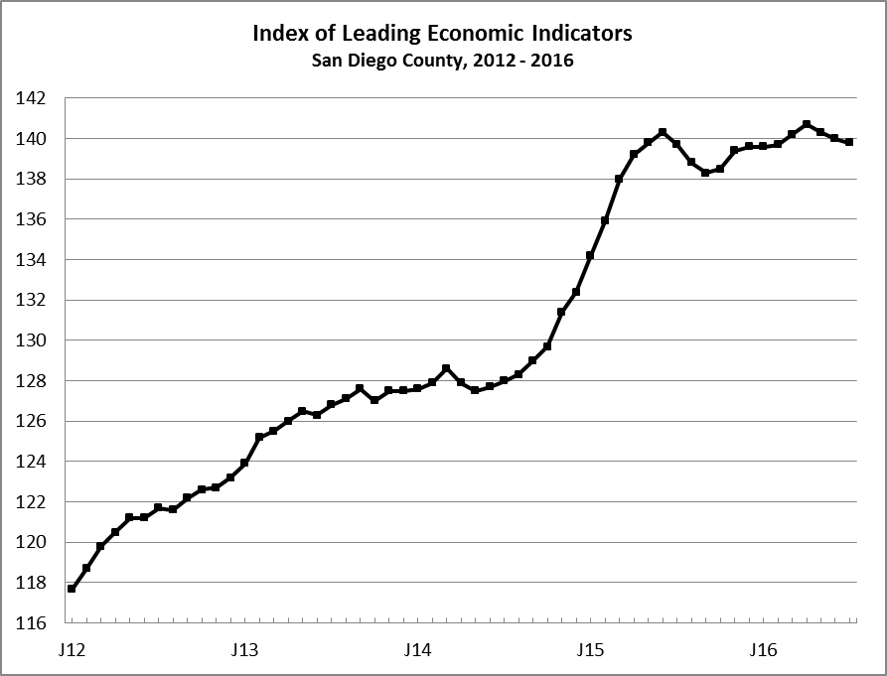
Index % Change

2015 AUG 138.8 -0.7
SEP 138.3 -0.4
OCT 138.5 +0.1
NOV 139.4 +0.7
DEC 139.6 +0.1

2016 JAN 139.6 +0.0
FEB 139.7 +0.1
MAR 140.2 +0.3
APR 140.7 +0.4
MAY 140.3 -0.3
JUN 140.0 -0.2
JUL 139.8 -0.1
AUG 139.9 +0.1

For more information on the University of San Diego's Index of Leading Economic Indicators, please contact:

Professor Alan Gin TEL: (858) 603-3873
School of Business Administration FAX: (619) 260-4891
University of San Diego E-mail: agin@sandiego.edu
5998 Alcalá Park Website: http://www.sandiego.edu/~agin/usdlei
San Diego, CA 92110 Twitter: @alanginusdsba

