Leading Economic Indicators Up Slightly in February
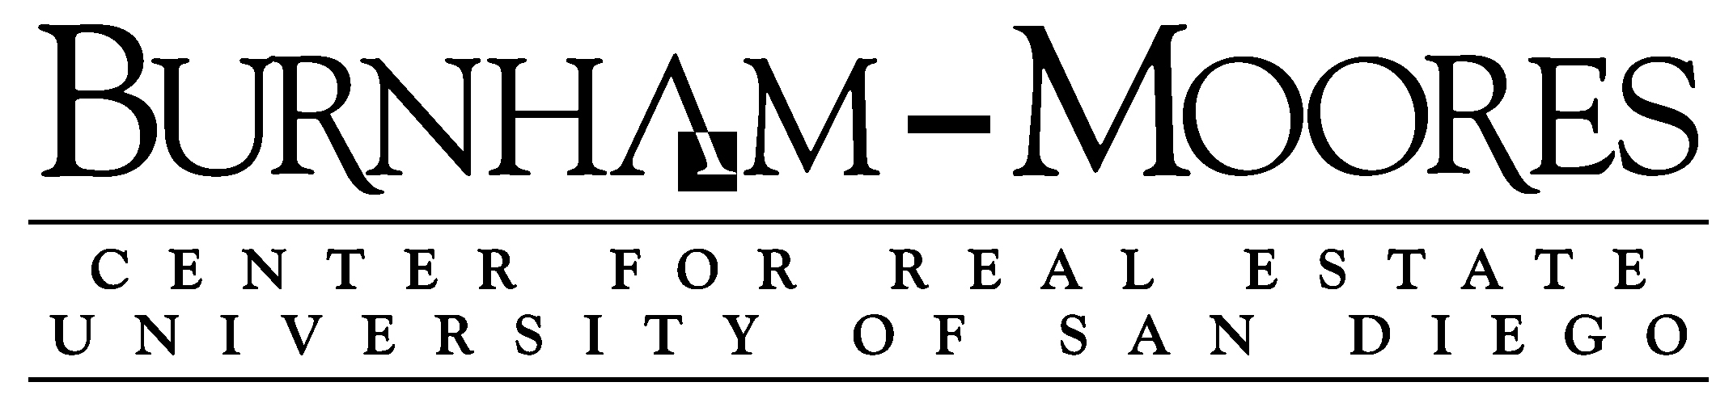

Note: The tentative release date of next month’s report is April 28.

March 31, 2016 -- The USD Burnham-Moores Center for Real Estate’s Index of Leading Economic Indicators for San Diego County rose 0.1 percent in February. The advance was led by a sharp increase in online help wanted advertising along with a moderate gain in initial claims for unemployment insurance. There were smaller gains in building permits and the outlook for the national economy. On the downside was another big loss for local stocks and a small decline in consumer confidence.

With February’s gain, the USD Index has now been positive four of the last five months. As a result, the outlook for the local economy remains positive for the rest of 2016. Since the last Leading Indicators report, the California Employment Development Department released its revised estimates of industry employment for 2015, produced in cooperation with the Bureau of Labor Statistics. The revised numbers show strong overall growth, with nearly 40,000 wage and salary jobs added in San Diego County last year. The one disappointing result of the revised data was that employment in the professional, scientific, and technical sectors grew at a much slower rate (2,400 jobs added) than had been initially reported. Almost all of the employment reports during 2015 indicated that it was the leading sector in terms of job growth, which was significant as the category included the important resource and development segment of the local economy. The sectors with the largest job growth were health care (+7,300), leisure and hospitality (+7,000), construction (+5,700), government (+4,000), and manufacturing (+3,700).

 | Index of Leading Economic Indicators  The index for San Diego County that includes  the components listed below (February)  Source: USD Burnham-Moores Center for Real Estate | +0.1%
 | Building Permits  Residential units authorized by building  permits in San Diego County (February)  Source: Construction Industry Research Board | +0.32%
 | Unemployment Insurance  Initial claims for unemployment insurance in  San Diego County, inverted (February)  Source: Employment Development Department | +0.68%
 | Stock Prices  Bloomberg San Diego County Index (February)  Source: Bloomberg Business | -1.80%
 | Consumer Confidence  An index of consumer confidence in San Diego  County , estimated (February)  Source: The Conference Board | -0.35%
 | Help Wanted Advertising  An index of online help wanted advertising in  San Diego (February)  Source: The Conference Board | +1.43%
 | National Economy  Index of Leading Economic Indicators (February)  Source: The Conference Board | +0.16%

School of Business Administration
5998 Alcalá Park, San Diego, California 92110-2492 858/603-3873
Highlights: Of the six components in the USD Index, residential units authorized by building permits has the longest current positive streak, having increased every month since September of last year. Once again, multi-family units authorized led the move to the upside with more than 600 units authorized in February. . . The labor market components remain positive, with initial claims for unemployment insurance and help wanted advertising both advancing for the fourth consecutive month. Online help wanted advertising has been particularly strong the last three months. The net result was that the seasonally adjusted local unemployment rate was 4.7 percent in February, which was up from 4.6 percent in January but down from 5.5 percent in February 2015. The unemployment rates in the first two months of the year were the lowest since August 2007. . . Going in the other direction is consumer confidence, which fell for the fourth straight month. While the drops have not been large, there is a potential concern as consumer activity is typically more than two-thirds of all economic activity in an economy. . . For the second month in a row, local stock prices plunged. The USD Index uses an average of the closing prices for each trading day of the month to measure stock prices. This led to the drop appearing worse than it was because prices fell early in the month, were flat at a lower level during the middle parts of the month, and then only rose at the end. . . The national Index of Leading Economic Indicators returned to the positive side with a gain in February. Growth in the fourth quarter of 2015 was better than initially reported but was still weak, with the “third” estimate of Gross Domestic Product (GDP) growth for that quarter being 1.4 percent. That compares to the “advance” estimate 0.7 percent given in January and the “second” estimate of 1.0 percent released last month.

February’s increase puts the USD Index of Leading Economic Indicators for San Diego County at 139.7, up from January’s reading of 139.6. While there was a revision in the national Index of Leading Economic Indicators for November, this did not affect either the previously reported changes in the Index or the Index levels themselves. For revisions to the previously reported values for the Index and for the individual components, please visit the Website address given below. The values for the USD Index for the last year are given below:

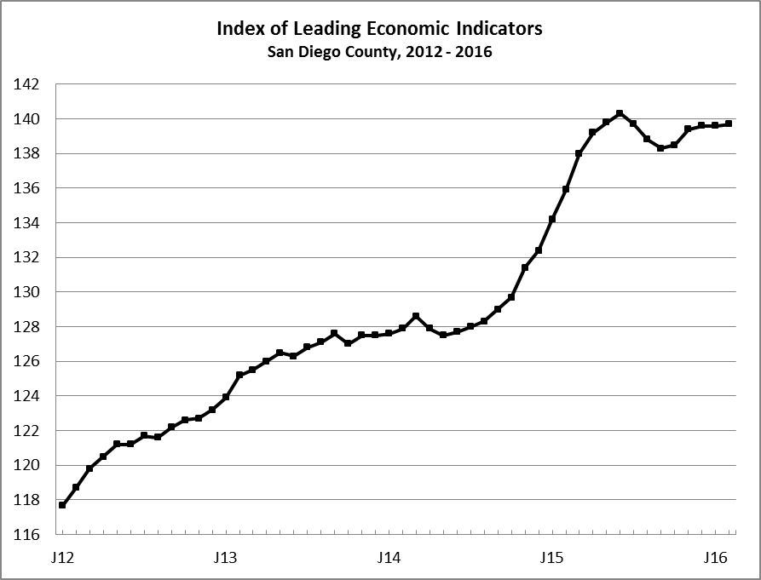
Index % Change

2015 FEB 135.9 +1.2
MAR 138.0 +1.5
APR 139.2 +0.9
MAY 139.8 +0.4
JUN 140.3 +0.4
JUL 139.7 -0.4
AUG 138.8 -0.7
SEP 138.3 -0.4
OCT 138.5 +0.1
NOV 139.4 +0.7
DEC 139.6 +0.1

2016 JAN 139.6 +0.0
FEB 139.7 +0.1

For more information on the University of San Diego's Index of Leading Economic Indicators, please contact:

Professor Alan Gin TEL: (858) 603-3873
School of Business Administration FAX: (619) 260-4891
University of San Diego E-mail: agin@sandiego.edu
5998 Alcalá Park Website: http://www.sandiego.edu/~agin/usdlei
San Diego, CA 92110 Twitter: @alanginusdsba

