Leading Economic Indicators Up in March
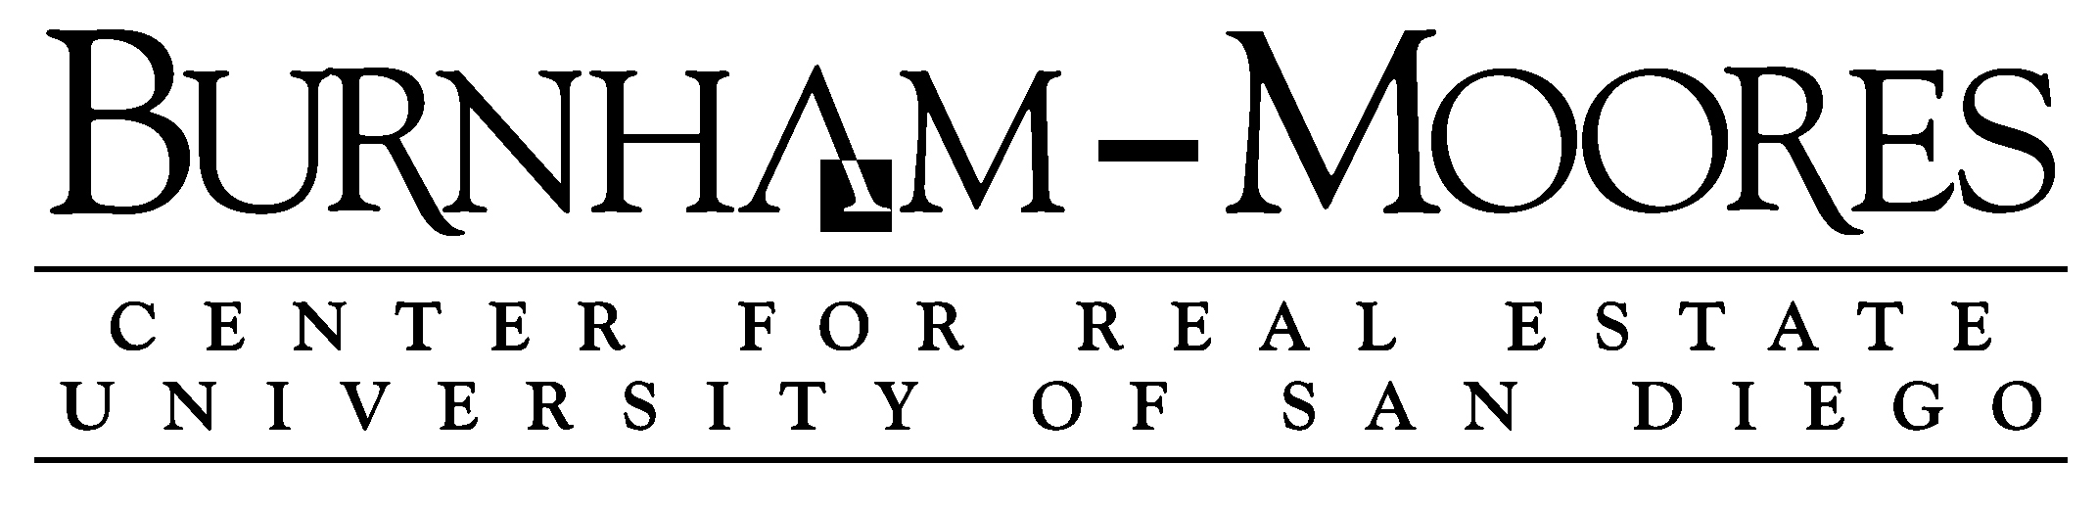

Note: The tentative release date of next month’s report is May 31.

April 28, 2016 -- The USD Burnham-Moores Center for Real Estate’s Index of Leading Economic Indicators for San Diego County rose 0.4 percent in March. Strong positive moves in initial claims for unemployment insurance and local stock prices led the move to the upside. There were also moderate gains in help wanted advertising and the outlook for the national economy. These advances overwhelmed a big dip in building permits and a small decline in consumer confidence to push the USD Index to its fifth increase in six months.

March’s gain was solid but not spectacular. The local economy remains on track to have good year. Through the first three months of the year, job growth hovers near the 40,000 mark in terms of year-over-year growth in wage and salary employment. The main worries are external forces, specifically, the health of the national and international economies. The International Monetary Fund is projecting global growth of 3.2 percent, up slightly from the 2015 growth rate. Growth in China is expected to continue slowing, although remaining above the 6 percent level. There continues to be turmoil in Europe with financial problems, concerns over immigration, and the possible exit of Britain from the European Union. In the United States, employment growth remains strong but Gross Domestic Product (GDP) growth is weak (see below). That prompted the Federal Reserve to decide in its April meeting to leave interest rates unchanged. The Fed cited weak growth and inflation being under the target rate of 2 percent. Interest rates are expected though to increase one or two more times in 2016.

 | Index of Leading Economic Indicators  The index for San Diego County that includes  the components listed below (March)  Source: USD Burnham-Moores Center for Real Estate | +0.4%
 | Building Permits  Residential units authorized by building  permits in San Diego County (March)  Source: Construction Industry Research Board | -0.87%
 | Unemployment Insurance  Initial claims for unemployment insurance in  San Diego County, inverted (March)  Source: Employment Development Department | +1.14%
 | Stock Prices  Bloomberg San Diego County Index (March)  Source: Bloomberg Business | +1.39%
 | Consumer Confidence  An index of consumer confidence in San Diego  County , estimated (March)  Source: The Conference Board | -0.14%
 | Help Wanted Advertising  An index of online help wanted advertising in  San Diego (March)  Source: The Conference Board | +0.37%
 | National Economy  Index of Leading Economic Indicators (March)  Source: The Conference Board | +0.48%

School of Business Administration
5998 Alcalá Park, San Diego, California 92110-2492 858/603-3873
Highlights: Residential units authorized by building permits turned negative in March, breaking a string of six consecutive monthly increases. For the first quarter of 2016, residential units authorized were down 11.8 percent compared to the same period in 2015. Single-family units authorized were again the culprit, falling 38.2 percent in the quarter as compared to a gain of 3.3 percent in multi-family units authorized. . . Both labor market components continue to be strong. Initial claims for unemployment insurance and help wanted advertising each advanced for the fifth month in a row. The net result was that the seasonally adjusted local unemployment rate was 4.7 percent in March, which was unchanged from the same level in February but down from 5.4 percent in March 2015. . . Consumer confidence continues to slump, falling for the fifth consecutive month. The cause of this downturn is uncertain, as the news on unemployment, employment growth, and gas prices has been positive. . . After two very bad months to start the year, local stock prices rebounded strongly in March but still finished the first quarter down 7.91 percent. This severely underperformed the broader market averages, with the Dow Jones Industrial Average, the S&P 500 Index, and the NASDAQ Composite Index showing returns of +1.49 percent, +0.77 percent, and -0.75 percent respectively. . . A revision in the national Index of Leading Economic Indicators for February resulted in a negative turning point signal, with the national index falling for three straight months from December to February. The national index has been weak, with five negative readings and an unchanged one in the last nine months. This is reflected in the weak growth of GDP. The “advance” estimate of GDP growth in the first quarter of 2016 was only 0.5 percent, which is down from significantly from the 2.4 percent growth rate for 2015.

March’s increase puts the USD Index of Leading Economic Indicators for San Diego County at 140.2, up from February’s reading of 139.7. Revisions in building permits and the national Index of Leading Economic Indicators led to revisions in the previously reported change for December and in the level of the Index for December through February. For revisions to the previously reported values for the Index and for the individual components, please visit the Website address given below. The values for the USD Index for the last year are given below:

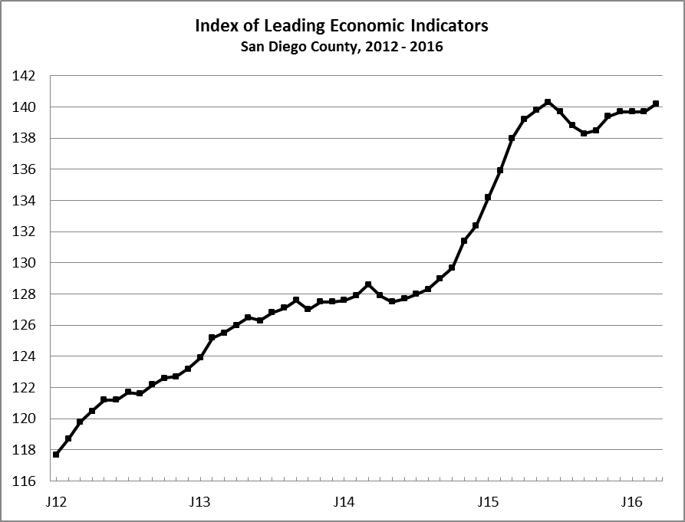
Index % Change

2015 MAR 138.0 +1.5
APR 139.2 +0.9
MAY 139.8 +0.4
JUN 140.3 +0.4
JUL 139.7 -0.4
AUG 138.8 -0.7
SEP 138.3 -0.4
OCT 138.5 +0.1
NOV 139.4 +0.7
DEC 139.7 +0.2

2016 JAN 139.7 +0.0
FEB 139.8 +0.1
MAR 140.4 +0.4

For more information on the University of San Diego's Index of Leading Economic Indicators, please contact:

Professor Alan Gin TEL: (858) 603-3873
School of Business Administration FAX: (619) 260-4891
University of San Diego E-mail: agin@sandiego.edu
5998 Alcalá Park Website: http://www.sandiego.edu/~agin/usdlei
San Diego, CA 92110 Twitter: @alanginusdsba

