Leading Economic Indicators Up in Novmeber
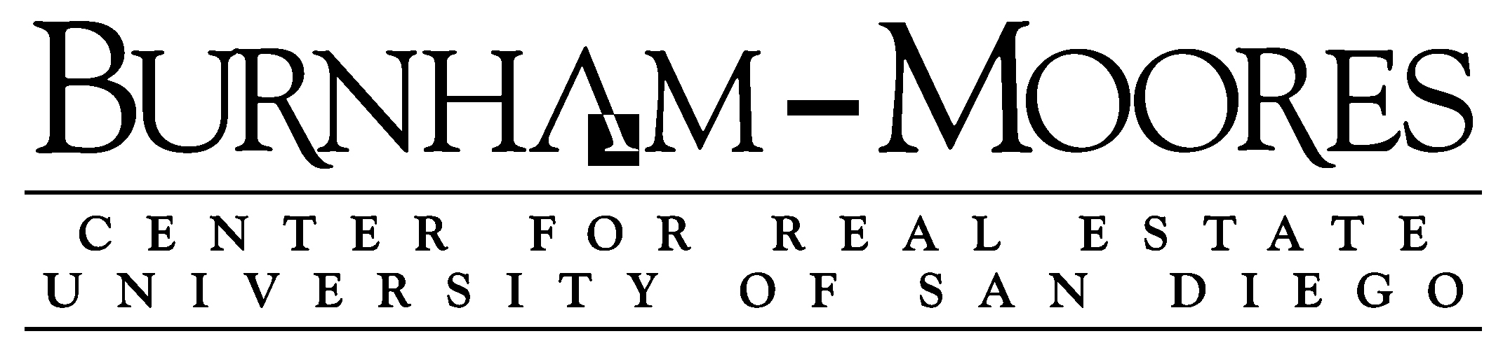

Note: The tentative release date for next month’s report is January 31.

This year’s San Diego County Economic Roundtable will be held on Thursday, January 19, from 8:30 – 12:00 at USD. For more information and registration, please go to http://www.sandiegocounty.gov/economicroundtable/.

January 5, 2017 -- The USD Burnham-Moores Center for Real Estate’s Index of Leading Economic Indicators for San Diego County rose 0.3 percent in November. Solid gains were posted by residential units authorized by building permits, initial claims for unemployment insurance, and consumer confidence. On the downside, there were small declines in local stock prices and help wanted advertising. The outlook for the national economy was unchanged.

November’s increase in the USD Index was the strongest since April and would have been even stronger except for anomaly in how the local stock prices are calculated (see below). But the gain was only the second since April, compared to four down months and an unchanged one. While November’s increase is welcome news, more is needed in the coming months to adjust the outlook, which is currently for a positive but slower growing local economy in 2017. Wage and salary employment is expected to increase by about 25,000 in the county during the year, which is less than what the region has been experiencing in the last few years. Because of the slower rate of job growth, the local unemployment rate is expected to increase slightly to 4.6 percent from the current 4.3 percent. Higher interest rates and affordability issues will limit housing prices, which are expected to increase by low single digits in the coming year.

 | Index of Leading Economic Indicators  The index for San Diego County that includes  the components listed below (October)  Source: USD Burnham-Moores Center for Real Estate | +0.3%
 | Building Permits  Residential units authorized by building  permits in San Diego County (October)  Source: U.S. Census Bureau | +0.81%
 | Unemployment Insurance  Initial claims for unemployment insurance in  San Diego County, inverted (October)  Source: Employment Development Department | +0.62%
 | Stock Prices  Bloomberg San Diego County Index (October)  Source: Bloomberg Business | -0.34%
 | Consumer Confidence  An index of consumer confidence in San Diego  County , estimated (October)  Source: The Conference Board | +0.98%
 | Help Wanted Advertising  An index of online help wanted advertising in  San Diego (October)  Source: The Conference Board | -0.33%
 | National Economy  Index of Leading Economic Indicators (October)  Source: The Conference Board | +0.00%

School of Business Administration
5998 Alcalá Park, San Diego, California 92110-2492 858/603-3873
Highlights: November is usually the worst month of the year for residential units authorized by building permits, but strong numbers for multi-family units authorized pushed the component to a second straight gain. . . The labor market variables continued to be mixed. November is usually the best month of the year for initial claims for unemployment insurance, but the component was positive, even with seasonal adjustment. Help wanted advertising moved in the opposite direction and has now declined for eight straight months. The net result was that the seasonally adjusted local unemployment rate was 4.3 percent in November, which was down from 4.8 percent in October and from 5.0 percent in November 2015. . . Consumer confidence has risen sharply since the election and has increased for five consecutive months. . . Local stock prices were considered down in November even though they were higher at the end of the month than at the beginning. This is because the value of stock prices for a month is calculated by taking the average of all the daily closing values of the local stock index for that month. Strength at the beginning of October and weakness at the beginning of November led to the odd result. Also, while the broader market averages were reaching record highs after the election, local stock prices are more than seven percent below the high reached on September 22. . . Although there was no change in the national Index of Leading Economic Indicators, the national economic news remains positive, with 178,000 jobs added during in November and the national unemployment rate falling to 4.6 percent. The third and final estimate for GDP growth for the third quarter was good, coming in at 3.5 percent, compared to the second estimate of 3.2 percent and the “advance” estimate of 2.9 percent.

November’s increase puts the USD Index of Leading Economic Indicators for San Diego County at 140.2, up from October’s revised reading of 139.8. Revisions in the national Index of Leading Economic for September and local stock prices for October led to the value of the Index being revised downward from the previously reported value of 139.9 and the change for the month going from unchanged to -0.1 percent. To view the previously reported values for the Index and for the individual components, please visit the Website address given below. The values for the USD Index for the last year are given below:

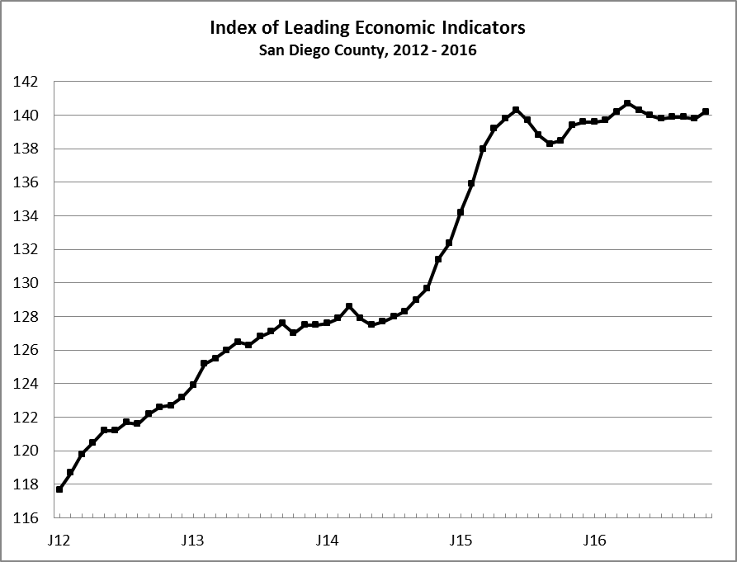
Index % Change

2015 NOV 139.4 +0.7
DEC 139.6 +0.1

2016 JAN 139.6 +0.0
FEB 139.7 +0.1
MAR 140.2 +0.3
APR 140.7 +0.4
MAY 140.3 -0.3
JUN 140.0 -0.2
JUL 139.8 -0.1
AUG 139.9 +0.1
SEP 139.9 +0.0
OCT 139.8 -0.1
NOV 140.2 +0.3

For more information on the University of San Diego's Index of Leading Economic Indicators, please contact:

Professor Alan Gin TEL: (858) 603-3873
School of Business Administration FAX: (619) 260-4891
University of San Diego E-mail: agin@sandiego.edu
5998 Alcalá Park Website: http://www.sandiego.edu/~agin/usdlei
San Diego, CA 92110 Twitter: @alanginusdsba

