Leading Economic Indicators Up in March
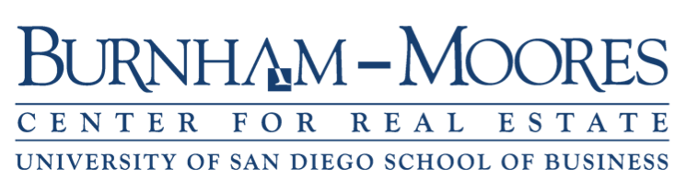

Note: The tentative release date for the report for April is May 31.

April 30, 2018 -- The USD Burnham-Moores Center for Real Estate’s Index of Leading Economic Indicators for San Diego County rose 0.5 percent in March. Leading the way to the upside was a strong positive move by initial claims for unemployment insurance. Also up but to a lesser extent were local stock prices, consumer confidence, help wanted advertising, and the outlook for the national economy. The only down component was residential units authorized by building permits, which were down moderately.

March’s increase marked the 17th straight month that the USD Index has advanced or remained unchanged (15 of those months were increases). It was also the third consecutive month that it has hit an all-time high. The outlook for the local economy thus continues to be positive at least through the end of 2018. Job growth for the first quarter of 2018 in San Diego County was solid, with wage and salary employment increasing by 26,700 compared to the same quarter in 2017. That is a slightly below the gain of 28,600 jobs for 2017 as a whole. The strongest sectors were health care (+5,500 jobs), professional, scientific, and technical services (+4,500), construction (+4,200), manufacturing (+3,800), and government (+3,300). While health care, construction, and government have been doing well recently, it is encouraging to see a pickup in professional, scientific, and technical services and manufacturing, as jobs in those sectors tend to be higher paying ones. The lagging sectors were finance and insurance (-400) and leisure and hospitality (-800).

 | Index of Leading Economic Indicators  The index for San Diego County that includes  the components listed below (March)  Source: USD Burnham-Moores Center for Real Estate | +0.5%
 | Building Permits  Residential units authorized by building  permits in San Diego County (March)  Source: U.S. Census Bureau | -0.68%
 | Unemployment Insurance  Initial claims for unemployment insurance in  San Diego County, inverted (March)  Source: Employment Development Department | +1.56%
 | Stock Prices  Bloomberg San Diego County Index (March)  Source: Bloomberg Business | +0.88
 | Consumer Confidence  An index of consumer confidence in San Diego  County , estimated (March )  Source: The Conference Board | +0.35%
 | Help Wanted Advertising  An index of online help wanted advertising in  San Diego (March )  Source: The Conference Board | +0.27%
 | National Economy  Index of Leading Economic Indicators (March)  Source: The Conference Board | +0.56%

School of Business
5998 Alcalá Park, San Diego, California 92110-2492 (858) 603-3873
Highlights: After three consecutive monthly gains, residential units authorized by building permits turned down in March. Despite that, it was a good first quarter for building permits, as residential units authorized were more than doubled (+102 percent) compared to the same quarter in 2017. As has been the case in recent years, multi-family units authorized led the way, being up 150 percent in 2018. But single-family units authorized also had a nice gain of 47 percent. . . Both labor market variables were up during the month. Initial claims for unemployment insurance followed a strong February with a nearly as good March, indicating that job loss remains low. Although help wanted advertising was up for the fifth straight month, the gain in March was the weakest of the five month. The net result was that the seasonally adjusted unemployment rate for San Diego County was 3.2 percent in March, which was down from 3.5 percent in February and from 4.2 percent in March 2017. . . Local stock prices reversed course after a decline in February. For the first quarter, local stock prices were up 3.13 percent. This outpaced the broader market averages, with the Dow Jones Industrial Average and Standard and Poor’s 500 Index actually declining in the quarter (-2.49 percent and -1.22 percent respectively) while the NASDAQ Composite Index was up 2.32 percent.. . . Consumer confidence was up for the 21st consecutive month. . . The national Index of Leading Economic Indicators has now increased or been unchanged for 19 months in a row. Despite that, growth continues to be sluggish, with the “advance” estimate of GDP for the first quarter of 2018 coming in at 2.3 percent. This matches the growth rate for 2017 as a whole, but was down from the 2.9 percent growth rate of the fourth quarter.

February’s gain puts the USD Burnham-Moores Index of Leading Economic Indicators for San Diego County at 153.0, up from January’s reading of 152.2. Revisions in the national Index of Leading Economic Indicators for October 2017 and February 2018 affected the previously reported changes for October and February and the levels of the Index for October and November. To view the previously reported values for the Index and for the individual components, please visit the Website address given below. The values for the USD Index for the last year are given below:

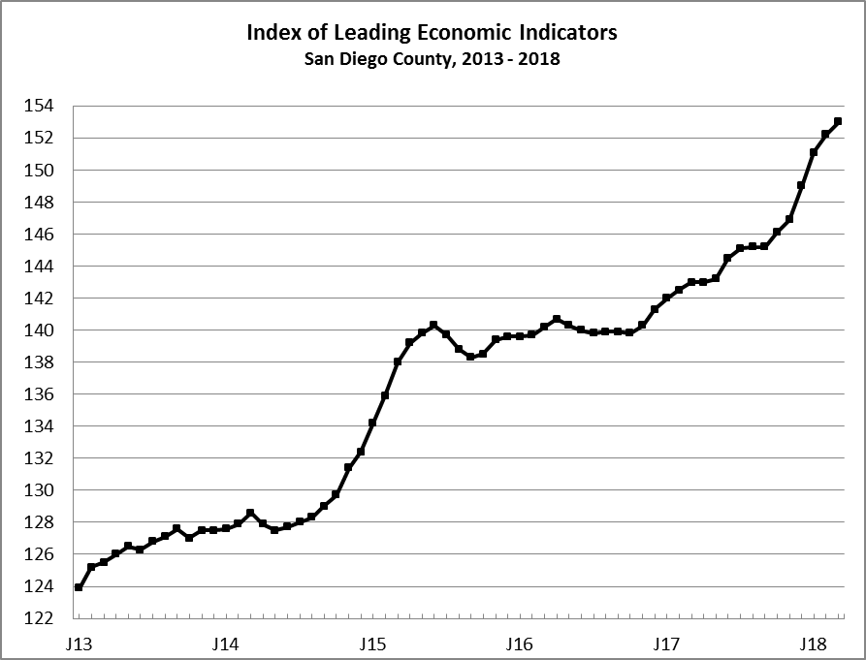
Index % Change

2017 MAR 143.0 +0.4
APR 143.0 +0.0
MAY 143.2 +0.1
JUN 144.5 +0.9
JUL 145.1 +0.5
AUG 145.2 +0.1
SEP 145.2 +0.0
OCT 146.1 +0.6
NOV 146.9 +0.5
DEC 149.0 +1.4

2018 JAN 151.1 +1.4
FEB 152.2 +0.8
MAR 153.0 +0.5

For more information on the University of San Diego's Index of Leading Economic Indicators, please contact:

Professor Alan Gin TEL: (858) 603-3873
School of Business Administration FAX: (619) 260-4891
University of San Diego E-mail: agin@sandiego.edu
5998 Alcalá Park Website: goo.gl/CV7Stc
San Diego, CA 92110 Twitter: @alanginusdsba

